四方达项目镜像构建步骤
1.安装操作系统选择openEuler24.03LTS
2.安装lnmp 参考滨州的离线安装包
3.修改mysql5.6
4.安装redis5
5.安装php7.4
6.php7.3安装mq，redis扩展
7.php7.4安装mq，redis扩展
8.部署两个项目，web服务端口配置成：80、81
9.配置nginx，映射两个项目
12.配置cron脚本
13.Supervisor守护进程安装配置
14.部署项目

社区镜像
openEuler24.03LTS
openEuler系统安装
设置好root 的密码9sKp7$Lz2&qR8_vB5
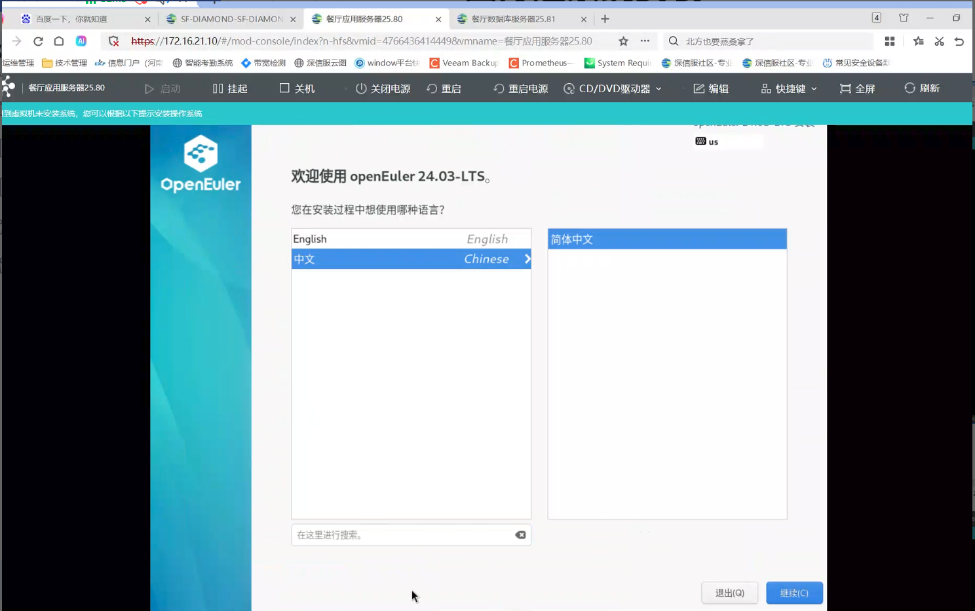
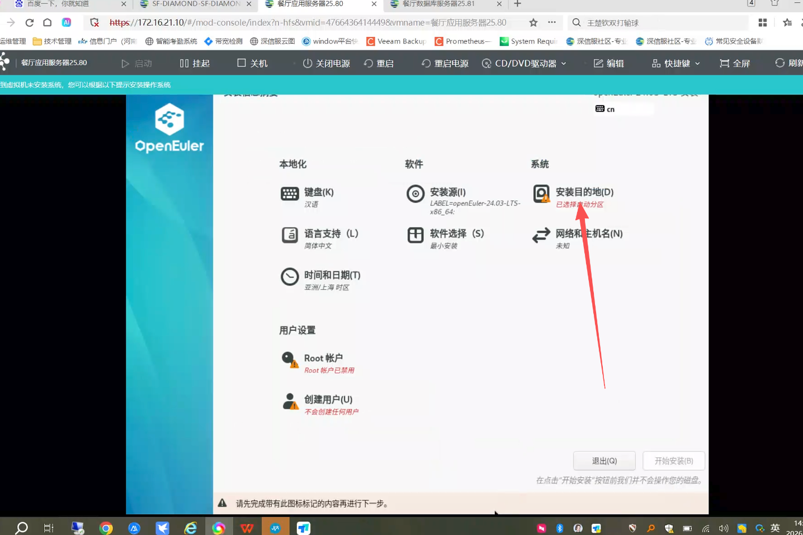
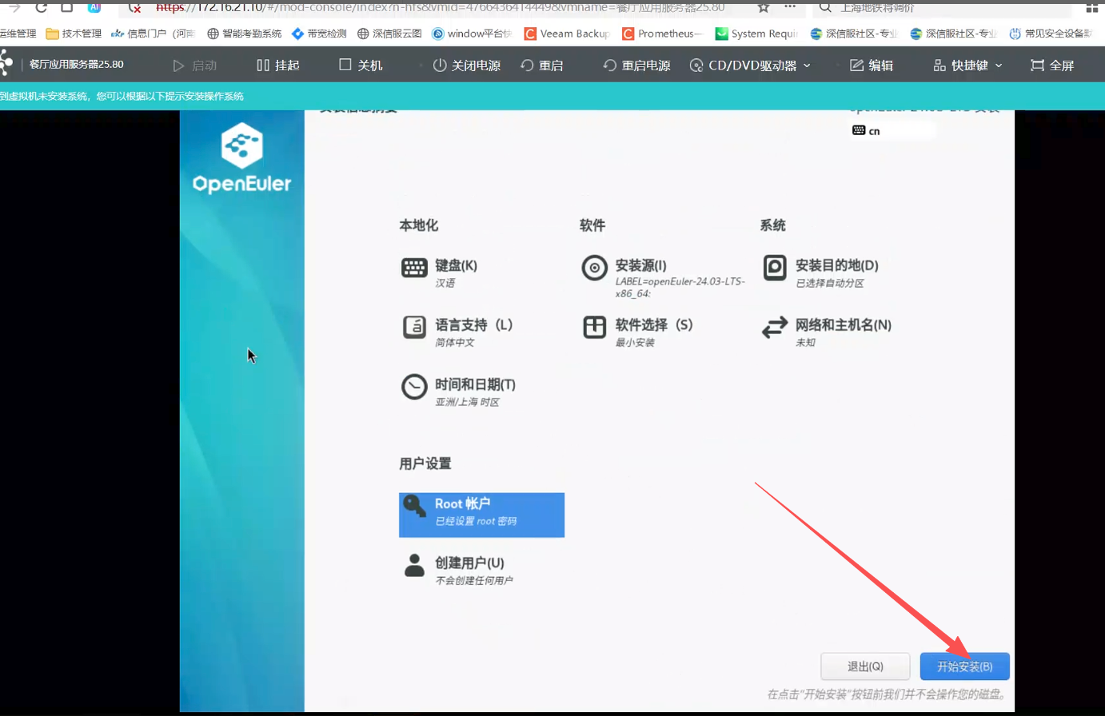
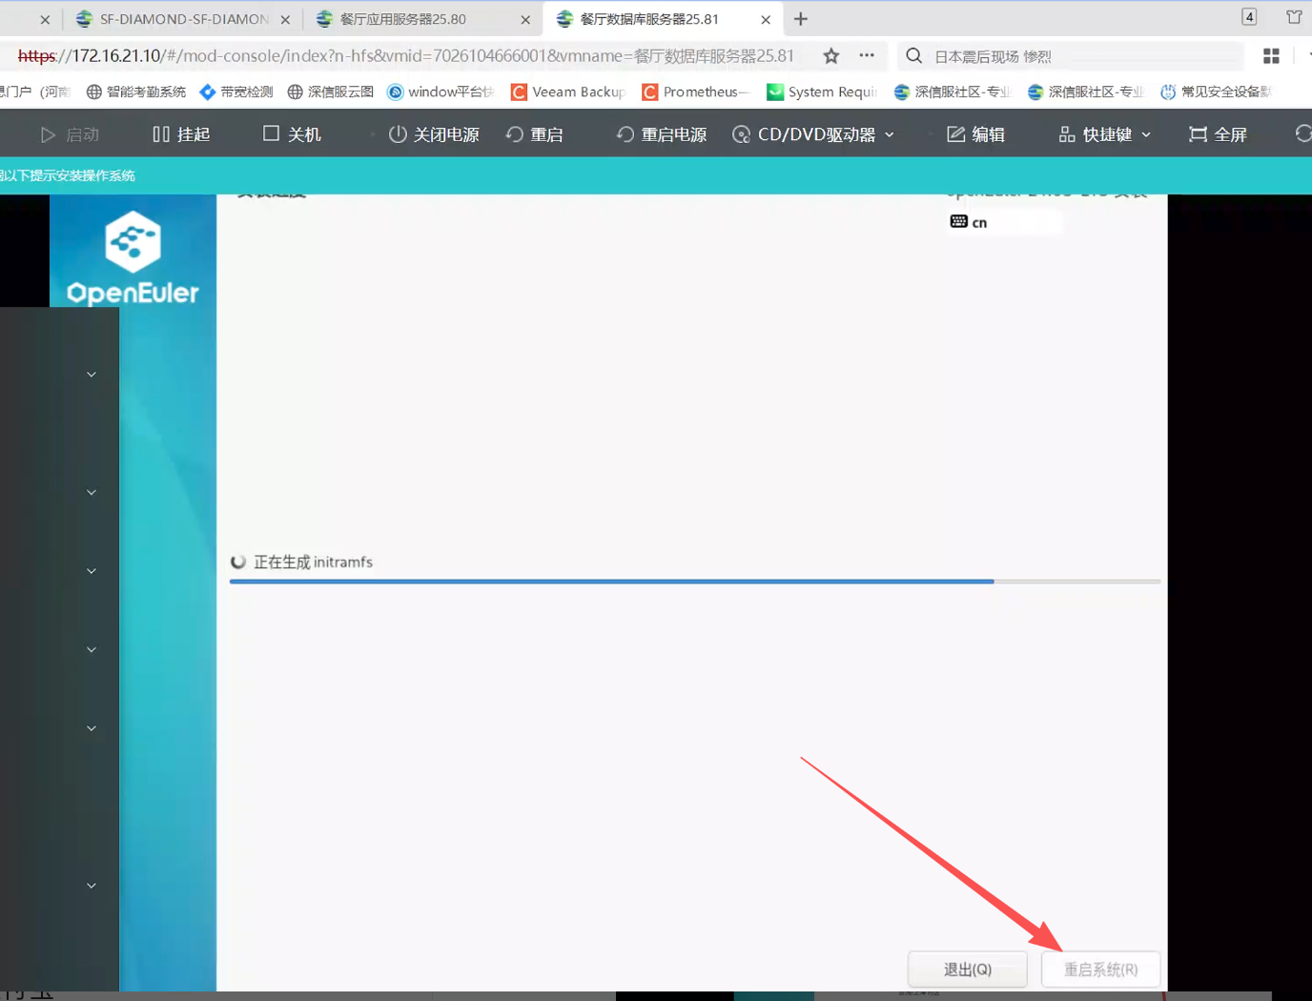
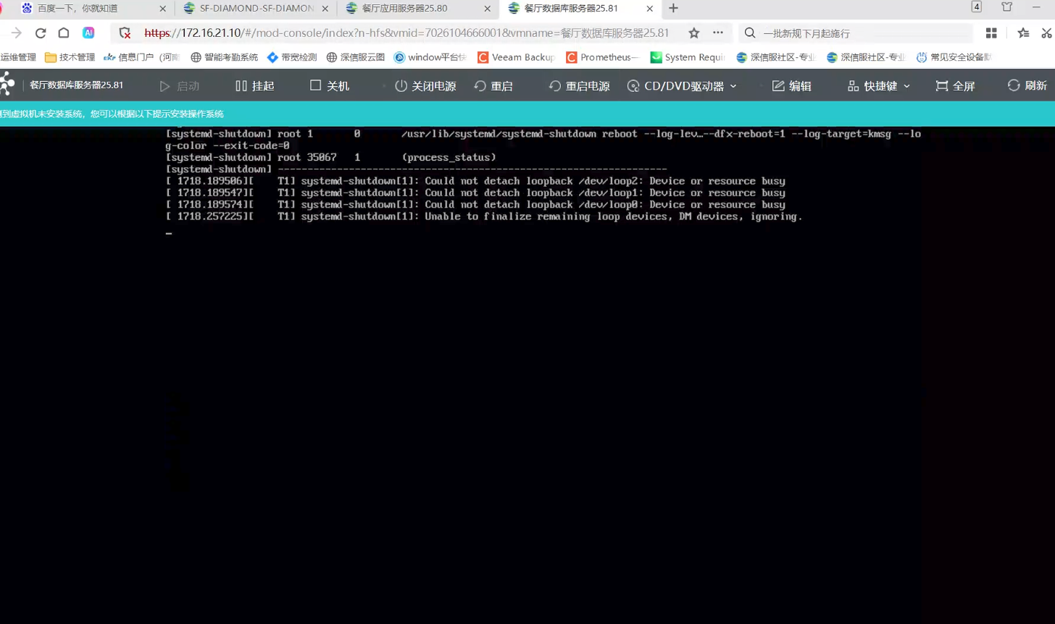
设置内网ip，
系统已成功启动，网卡 ens18 处于 UP 状态，但 ip addr 输出中没有业务 IPv4 地址。NetworkManager 连接 ens18 的 ipv4.method 为 auto，未取得地址、网关和 DNS。

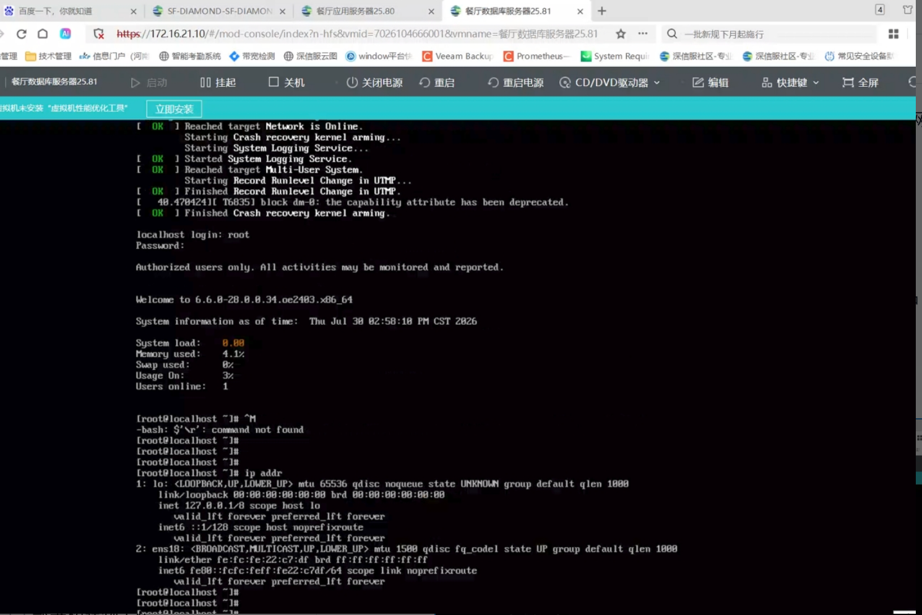
数据库服务器配置（172.16.25.81）
nmcli connection modify ens18 ipv4.method manual ipv4.addresses 172.16.25.81/24 ipv4.gateway 172.16.25.1 ipv4.dns 192.168.1.49 connection.autoconnect yes
nmcli connection up ens18
ip -br addr show ens18
ping -c 3 172.16.25.1
ping -c 3 192.168.1.49
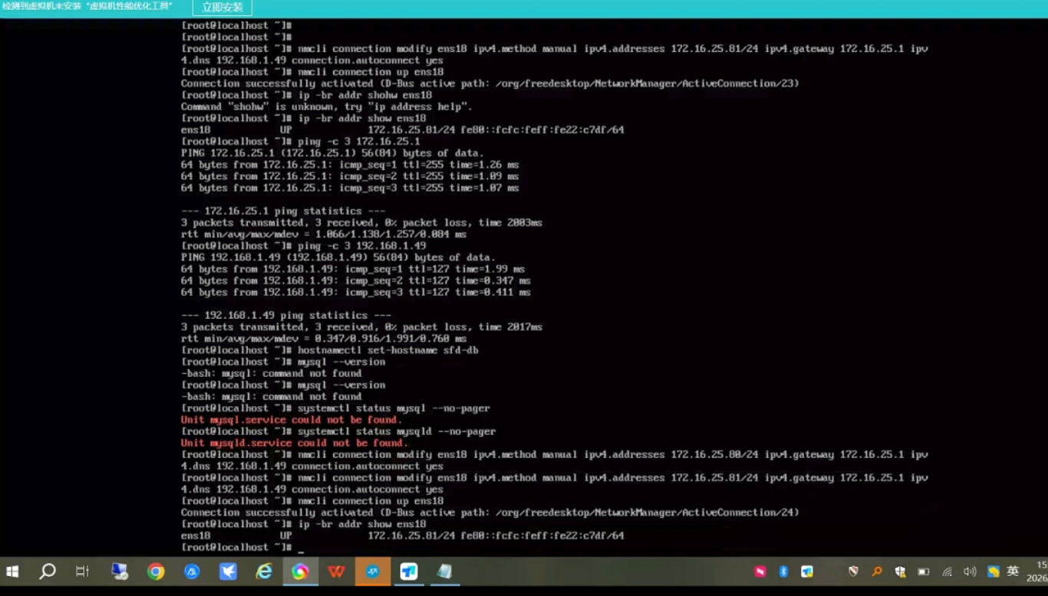
应用服务器配置（172.16.25.80）
nmcli connection modify ens18 ipv4.method manual ipv4.addresses 172.16.25.80/24 ipv4.gateway 172.16.25.1 ipv4.dns 192.168.1.49 connection.autoconnect yes
nmcli connection up ens18
ip -br addr show ens18
ping -c 3 172.16.25.1
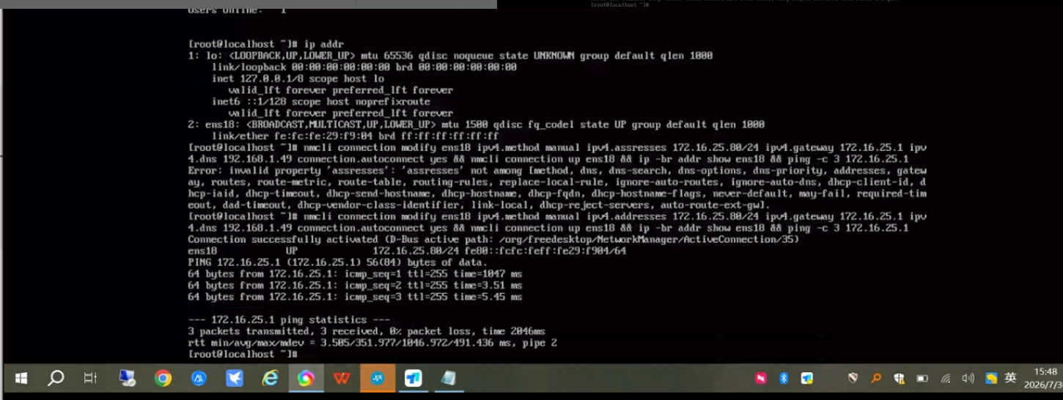

四方达项目部署详细步骤
登录服务器
ssh root@172.16.25.80
输入密码
登录成功
安装lnmp 参考滨州的离线安装包

安装mysql5.6
选3
密码cpt2018@)!(
其他回车
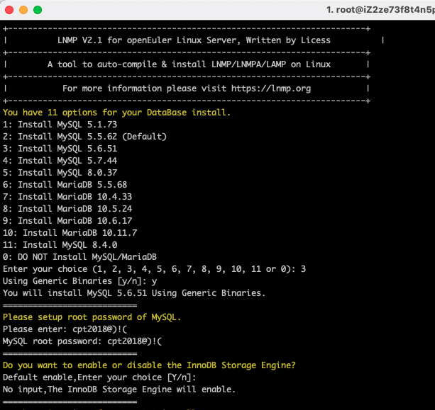
安装php7.3
选9
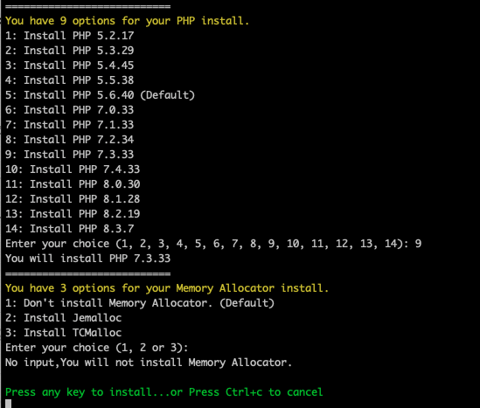
Press any key to install...or Press Ctrl+c to cancel

You will install lnmp stack.
nginx-1.26.0
mysql-5.6.51
php-7.3.33
安装成功
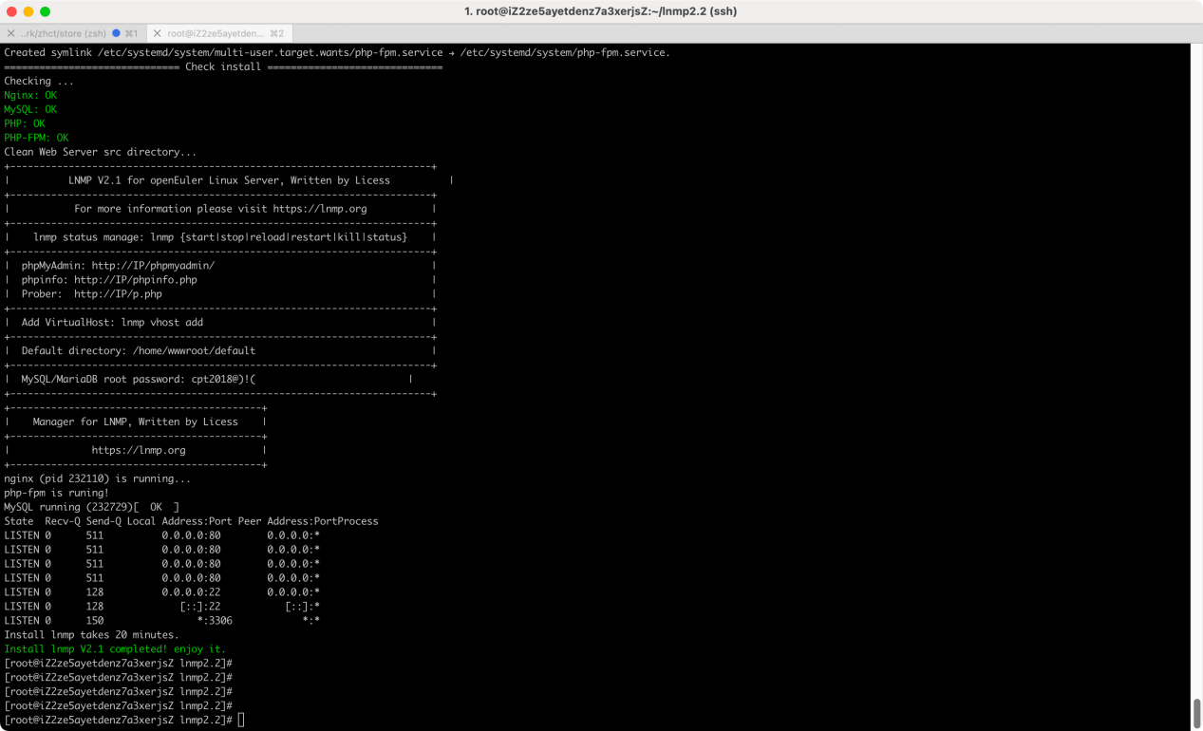
检查安装
nginx -v # 查看 Nginx 版本
nginx -t # 检查配置文件是否正确
systemctl start nginx # 启动 Nginx
systemctl status nginx # 查看运行状态
[root@iZ2ze73f8t4n5pqq32hrsyZ lnmp2.2]# mysql -V
mysql Ver 14.14 Distrib 5.6.51, for linux-glibc2.12 (x86_64) using EditLine wrapper
[root@iZ2ze73f8t4n5pqq32hrsyZ lnmp2.2]# php -v
PHP 7.3.33 (cli) (built: Jul 23 2025 15:29:14) ( NTS )
Copyright (c) 1997-2018 The PHP Group
Zend Engine v3.3.33, Copyright (c) 1998-2018 Zend Technologies
[root@iZ2ze73f8t4n5pqq32hrsyZ lnmp2.2]# nginx -v # 查看 Nginx 版本
nginx version: nginx/1.26.0
[root@iZ2ze73f8t4n5pqq32hrsyZ lnmp2.2]#

优化nginx配置
1）日志位置：新建日志目录
mkdir -p /workspace/wwwlogs/
2）统一配置
cd /usr/local/nginx/conf/
cat rewrite/thinkphp.conf
location / {
if (!-e $request_filename) {
rewrite ^/(.*)$ /index.php/$1 last;
break;
}
if ($request_uri = "/") {
return 301 http://$server_name:$server_port/dist/;
}

location /console/ {
if ($host ~* "yyangpt") {
rewrite ^/console/(.*)$ /Console/$1 permanent;
}
}

proxy_cookie_flags ~ secure;
proxy_cookie_flags ~ httponly;
}
cat enable-php7.4.conf
location ~ [^/]\.php(/|$)
{
fastcgi_pass unix:/tmp/php-cgi7.4.sock;
fastcgi_index index.php;
include fastcgi.conf;
include pathinfo.conf;
fastcgi_param SCRIPT_FILENAME $document_root$fastcgi_script_name;

if ($query_string ~ "^s=(.*)$") {
set $path_info "/$1";
}

}
cat enable-php.conf
location ~ [^/]\.php(/|$)
{
fastcgi_pass unix:/tmp/php-cgi.sock;
fastcgi_index index.php;
include fastcgi.conf;
include pathinfo.conf;
}
cat fastcgi.conf

fastcgi_param SCRIPT_FILENAME $document_root$fastcgi_script_name;
fastcgi_param QUERY_STRING $query_string;
fastcgi_param REQUEST_METHOD $request_method;
fastcgi_param CONTENT_TYPE $content_type;
fastcgi_param CONTENT_LENGTH $content_length;

fastcgi_param SCRIPT_NAME $fastcgi_script_name;
fastcgi_param REQUEST_URI $request_uri;
fastcgi_param DOCUMENT_URI $document_uri;
fastcgi_param DOCUMENT_ROOT $document_root;
fastcgi_param SERVER_PROTOCOL $server_protocol;
fastcgi_param REQUEST_SCHEME $scheme;
fastcgi_param HTTPS $https if_not_empty;

fastcgi_param GATEWAY_INTERFACE CGI/1.1;
fastcgi_param SERVER_SOFTWARE nginx/$nginx_version;

fastcgi_param REMOTE_ADDR $remote_addr;
fastcgi_param REMOTE_PORT $remote_port;
fastcgi_param SERVER_ADDR $server_addr;
fastcgi_param SERVER_PORT $server_port;
fastcgi_param SERVER_NAME $server_name;

# PHP only, required if PHP was built with --enable-force-cgi-redirect
fastcgi_param REDIRECT_STATUS 200;
fastcgi_param PHP_ADMIN_VALUE "open_basedir=$document_root/../:/tmp/:/proc/:/home/wwwroot/logs/:/workspace/wwwroot/log/";
cat ngixn.conf
user www www;

worker_processes auto;
worker_cpu_affinity auto;

error_log /workspace/wwwlogs/nginx_error.log crit;

pid /usr/local/nginx/logs/nginx.pid;

#Specifies the value for maximum file descriptors that can be opened by this process.
worker_rlimit_nofile 51200;

events
{
use epoll;
worker_connections 51200;
multi_accept off;
accept_mutex off;
}

http
{
include mime.types;
default_type application/octet-stream;

log_format main '$remote_addr - $remote_user [$time_local] "$request" '
'$request_time $upstream_response_time $request_length '
'$status $body_bytes_sent "$http_referer" '
'"$http_user_agent"';

server_names_hash_bucket_size 128;
client_header_buffer_size 32k;
large_client_header_buffers 4 32k;
client_max_body_size 50m;

sendfile on;
sendfile_max_chunk 512k;
tcp_nopush on;

keepalive_timeout 60;

tcp_nodelay on;

fastcgi_connect_timeout 300;
fastcgi_send_timeout 300;
fastcgi_read_timeout 300;
fastcgi_buffer_size 64k;
fastcgi_buffers 4 64k;
fastcgi_busy_buffers_size 128k;
fastcgi_temp_file_write_size 256k;

gzip on;
gzip_min_length 1k;
gzip_buffers 4 16k;
gzip_http_version 1.1;
gzip_comp_level 2;
gzip_types text/plain application/javascript application/x-javascript text/javascript text/css application/xml application/xml+rss;
gzip_vary on;
gzip_proxied expired no-cache no-store private auth;
gzip_disable "MSIE [1-6]\.";

#limit_conn_zone $binary_remote_addr zone=perip:10m;
##If enable limit_conn_zone,add "limit_conn perip 10;" to server section.

server_tokens off;
access_log off;

server
{
listen 80 default_server reuseport;
#listen [::]:80 default_server ipv6only=on;
server_name _;
index index.html index.htm index.php;
root /home/wwwroot/default;

#error_page 404 /404.html;

# Deny access to PHP files in specific directory
#location ~ /(wp-content|uploads|wp-includes|images)/.*\.php$ { deny all; }

include enable-php.conf;

location /nginx_status
{
stub_status on;
access_log off;
}

location ~ .*\.(gif|jpg|jpeg|png|bmp|swf)$
{
expires 30d;
}

location ~ .*\.(js|css)?$
{
expires 12h;
}

location ~ /.well-known {
allow all;
}

location ~ /\.
{
deny all;
}

access_log /workspace/wwwlogs/access.log;
}
include vhost/*.conf;
}
cat pathinfo.conf
fastcgi_split_path_info ^(.+?\.php)(/.*)$;
set $path_info $fastcgi_path_info;
fastcgi_param PATH_INFO $path_info;
测试配置是否有语法错误:sudo nginx -t
重启nginx：nginx -s reload
安装vim
yum install -y vim
配置mysql
cat /etc/my.cnf
vim /etc/my.cnf

[client]
#password = your_password
socket = /tmp/mysql.sock

[mysqld]
socket = /tmp/mysql.sock

重启 MySQL 服务
service mysql restart

[root@iZ2ze73f8t4n5pqq32hrsyZ lnmp2.2]# service mysql restart
Shutting down MySQL.. SUCCESS!
Starting MySQL.. SUCCESS!

移除sql_mode 中的严格模式参数

cat /usr/local/mysql/my.cnf

#sql_mode=NO_ENGINE_SUBSTITUTION,STRICT_TRANS_TABLES
sql-mode="NO_AUTO_CREATE_USER,NO_ENGINE_SUBSTITUTION"

重启mysql
sudo systemctl restart mysql
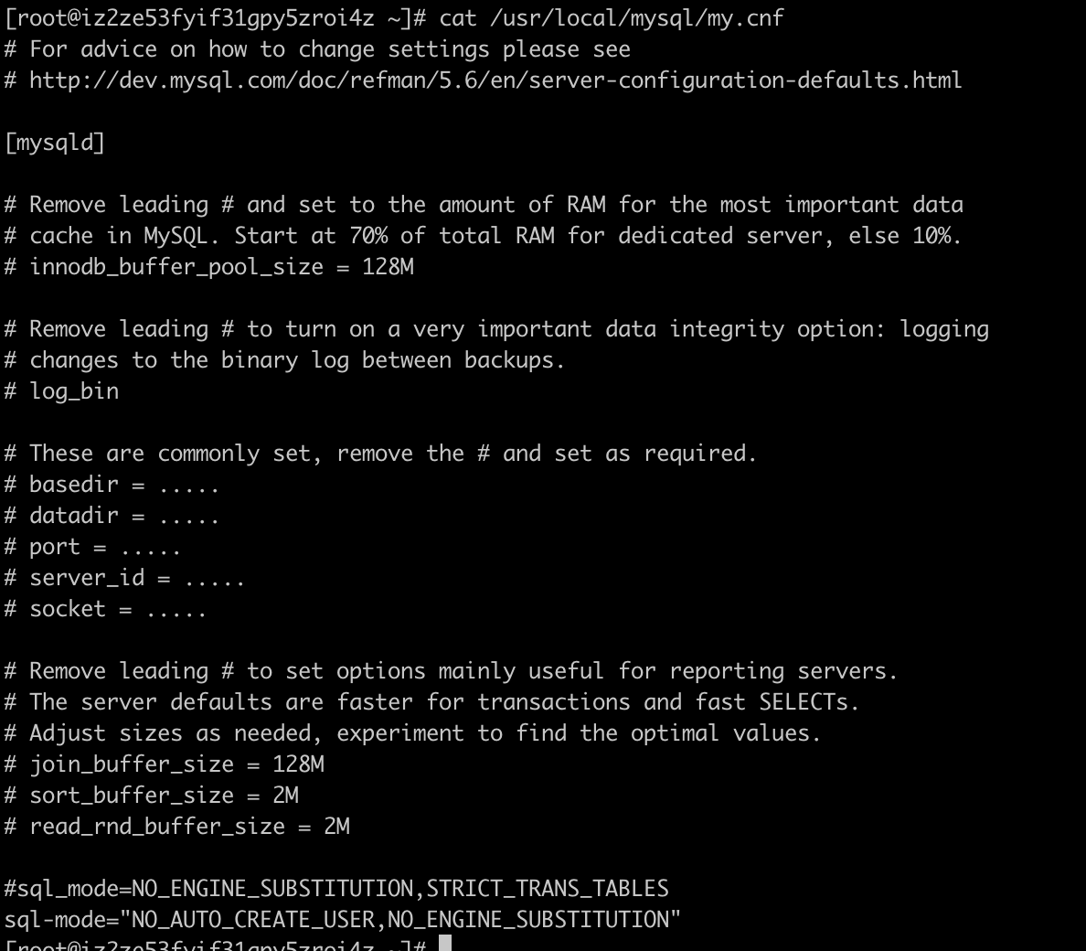

创建mysql账号：wwwweb，密码：cpt2018@)!(，授权全部权限，允许外网访问
# root登录mysql
mysql -u root -p -P 3306
cpt2018@)!(
# 检查用户是否允许远程访问%为任意外网 IP
SELECT User, Host FROM mysql.user;
# 允许用户wwwweb从任意外网 IP（%）访问：
CREATE USER 'wwwweb'@'%' IDENTIFIED BY 'cpt2018@)!(';
# 授权全部权限
GRANT ALL PRIVILEGES ON *.* TO 'wwwweb'@'%' WITH GRANT OPTION;
# 刷新权限
FLUSH PRIVILEGES;
# 查看权限
SHOW GRANTS FOR 'wwwweb'@'%';
# 检查用户是否允许远程访问%为任意外网 IP
SELECT User, Host FROM mysql.user;

Navicat链接数据库验证
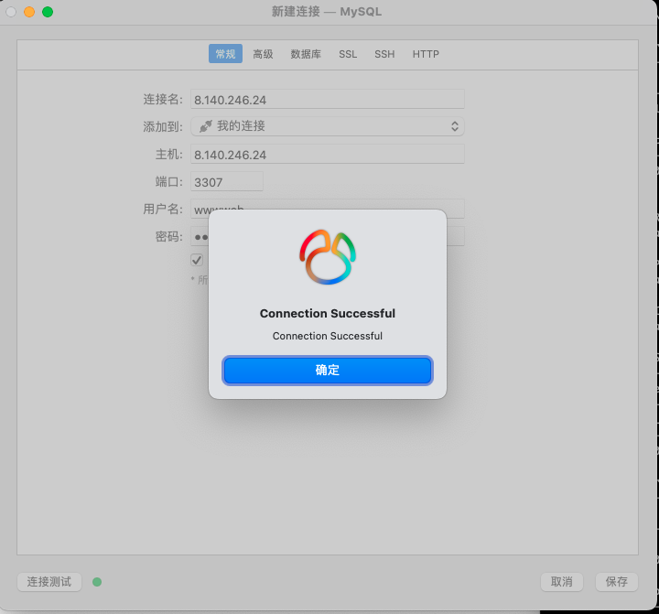
安装redis5
sudo dnf install -y redis5
配置redis5
vim /etc/redis.conf
# 允许远程访问（注释掉此行）
# bind 127.0.0.1
# 启用守护进程模式
daemonize yes
# 设置密码
# requirepass foobared
requirepass zhct:Cpt2024@)!(

# 启动Redis服务
sudo systemctl start redis
# 设置开机自启
sudo systemctl enable redis
# 检查服务状态
sudo systemctl status redis

# 连接Redis
redis-cli -h 127.0.0.1 -p 6379
# 若设置了密码，需先认证
127.0.0.1:6370> AUTH zhct:Cpt2024@)!(
# 测试Redis
127.0.0.1:6370> keys *
(empty list or set)
127.0.0.1:6370> PING
PONG

rdm链接redis验证
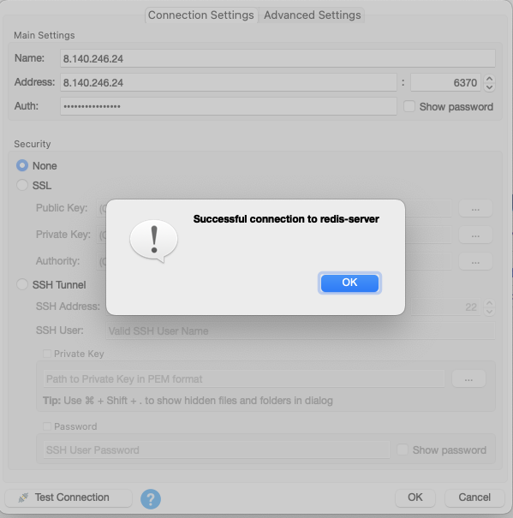
安装php7.4
1、lnmp解压目录下
cd /root/lnmp2.2
./install.sh mphp
选择安装的版本7.4，安装完成后/usr/local/nginx/conf下会多一个enable-php7.4.conf
2、启动多个php
# php7.3
/etc/init.d/php-fpm start
/etc/init.d/php-fpm7.4 start
查看启动的php
ps -ef | grep php
3、不同的项目选择不通的php版本
在每个项目对应的vhost中的配置文件中
include enable-php.conf;
另一个项目include enable-php7.4.conf;

# PHP 7.3
[root@iZ2ze5ayetdenz7a3xerjsZ lnmp2.2]# /usr/local/php/bin/php -v
PHP 7.3.33 (cli) (built: Jul 21 2025 18:36:23) ( NTS )
Copyright (c) 1997-2018 The PHP Group
Zend Engine v3.3.33, Copyright (c) 1998-2018 Zend Technologies
# PHP 7.4
[root@iZ2ze5ayetdenz7a3xerjsZ lnmp2.2]# /usr/local/php7.4/bin/php -v
PHP 7.4.33 (cli) (built: Jul 22 2025 11:16:34) ( NTS )
Copyright (c) The PHP Group
Zend Engine v3.4.0, Copyright (c) Zend Technologies
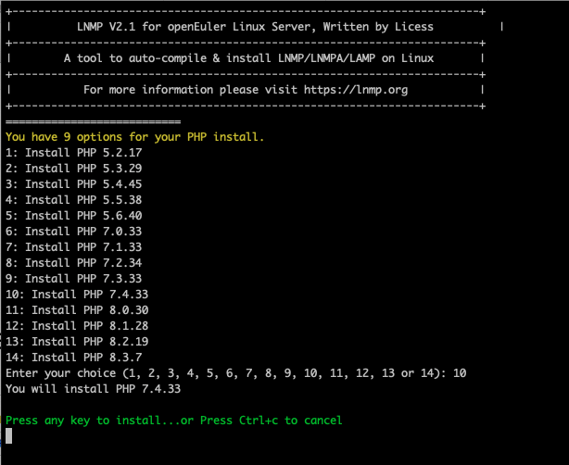

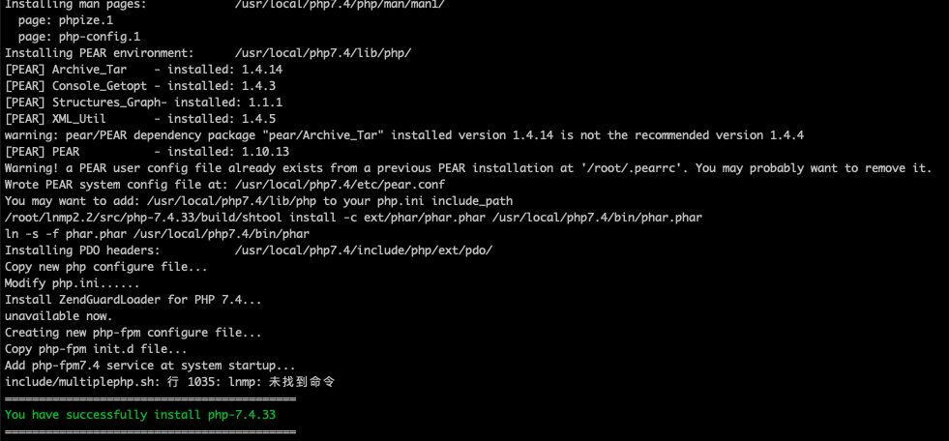
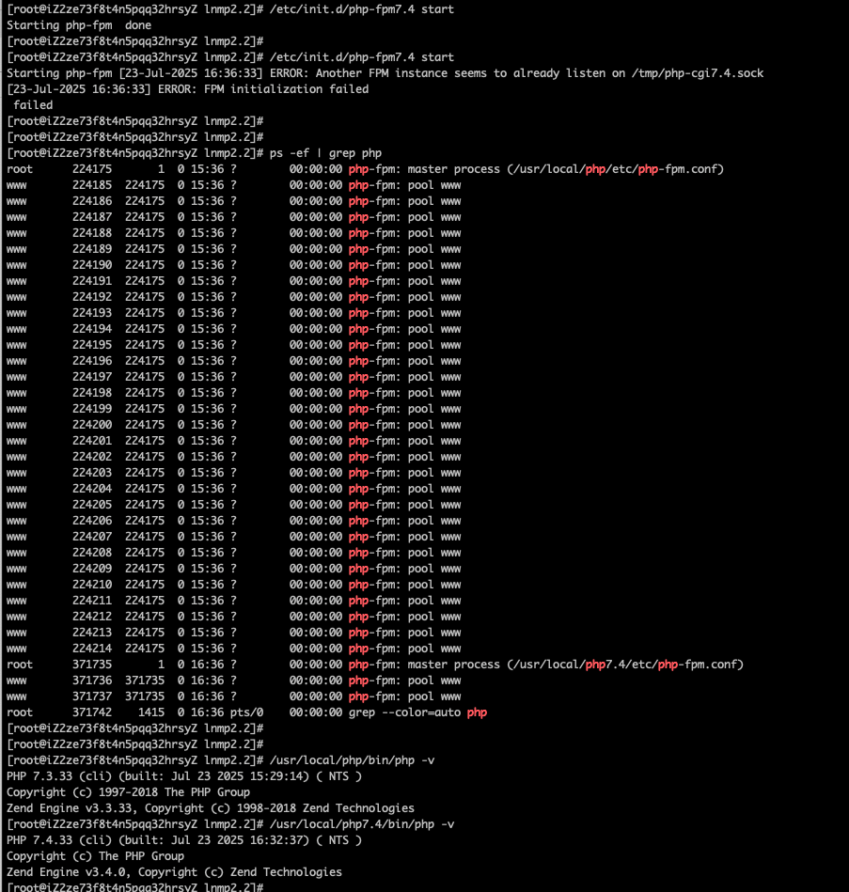
php7.3安装扩展
安装MQTT扩展：mosquitto.so
# 查看现有扩展
/usr/local/php/bin/php -m

# 开放必要函数
vim /usr/local/php/etc/php.ini
# 删掉312行的exec,readlink,popen,proc_open,proc_get_status

# 安装 Mosquitto 开发库PHP 的 Mosquitto 扩展依赖
# Mosquitto C 库（libmosquitto）及其开发头文件（libmosquitto-dev）
sudo dnf install -y mosquitto-devel

# 验证依赖是否安装
[root@iZ2ze5ayetdenz7a3xerjsZ lnmp2.2]# ls /usr/include/mosquitto.h
/usr/include/mosquitto.h
[root@iZ2ze5ayetdenz7a3xerjsZ lnmp2.2]# ls /usr/lib64/libmosquitto.so
/usr/lib64/libmosquitto.so

# 安装mosquitto.so扩展
/usr/local/php/bin/pecl install Mosquitto-alpha

# 配置ini文件
vim /usr/local/php/etc/php.ini

extension="mosquitto.so"

# 重启php7.3
# 删除： /tmp/php-cgi.sock
rm -rf /tmp/php-cgi.sock
# 再重新启动php7.3
/usr/local/php/sbin/php-fpm

# 查看现有扩展
/usr/local/php/bin/php -m
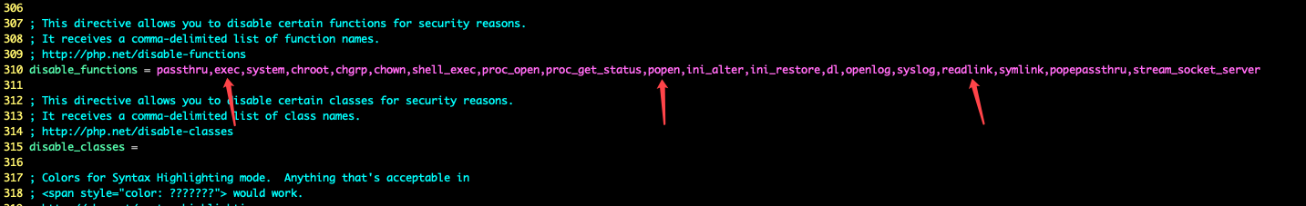
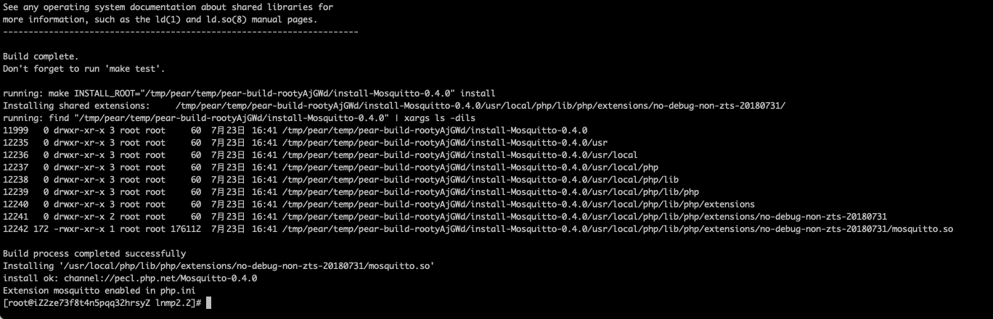
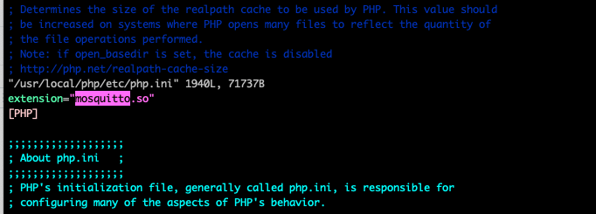
安装redis5扩展
/usr/local/php/bin/php -m
cd /root
wget http://pecl.php.net/get/redis-5.3.5.tgz
tar -zxvf redis-5.3.5.tgz
cd /root/redis-5.3.5
/usr/local/php/bin/phpize
./configure --with-php-config=/usr/local/php/bin/php-config --enable-redis
make
make install
vim /usr/local/php/etc/php.ini
/usr/local/php/bin/php -m
rm -rf /tmp/php-cgi.sock
/usr/local/php/sbin/php-fpm
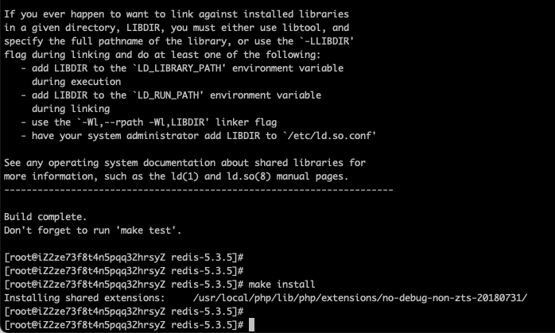
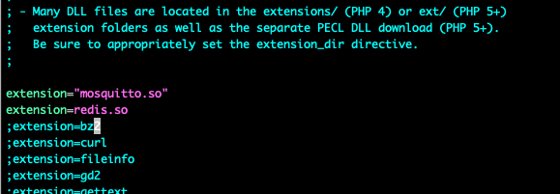
php7.4安装扩展
安装MQTT扩展：mosquitto.so
# 查看现有扩展
/usr/local/php7.4/bin/php -m

# 开放必要函数
vim /usr/local/php7.4/etc/php.ini
# 删掉312行的exec,readlink,popen,proc_open,proc_get_status

# 安装mosquitto.so扩展
/usr/local/php7.4/bin/pecl install Mosquitto-alpha
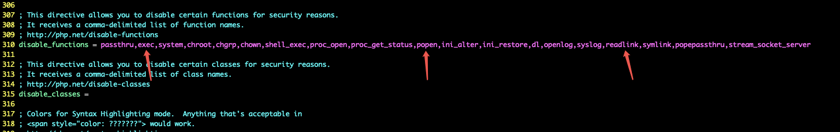
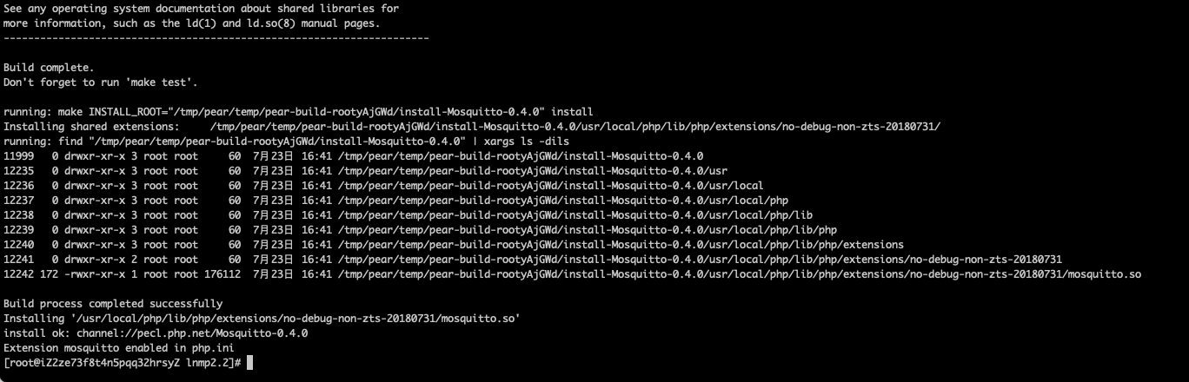
安装redis5扩展
cd /root
rm -rf redis-5.3.5
tar -zxvf redis-5.3.5.tgz
cd /root/redis-5.3.5
/usr/local/php7.4/bin/phpize
./configure --with-php-config=/usr/local/php7.4/bin/php-config --enable-redis
make
make install

# 配置ini文件
vim /usr/local/php7.4/etc/php.ini

extension="mosquitto.so"
extension=redis.so

# 查看扩展
/usr/local/php7.4/bin/php -m

# 重启php7.4
# 删除： /tmp/php-cgi7.4.sock
rm -rf /tmp/php-cgi7.4.sock
# 再重新启动php7.4
/usr/local/php7.4/sbin/php-fpm
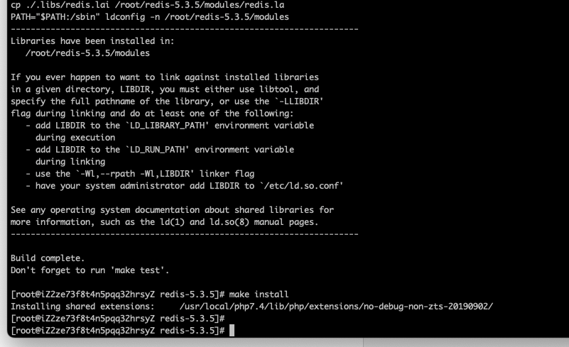
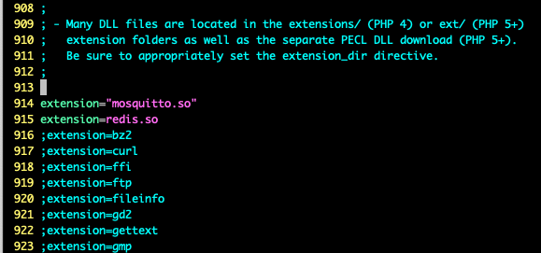

设置php7.3访问软连接
[root@iZ2ze12juwl7c3y6h920e8Z conf.d]#
[root@iZ2ze12juwl7c3y6h920e8Z conf.d]# mkdir -p /usr/local/php7.3/bin
[root@iZ2ze12juwl7c3y6h920e8Z conf.d]#
[root@iZ2ze12juwl7c3y6h920e8Z conf.d]# ln -s /usr/local/php/bin/php /usr/local/php7.3/bin/php
[root@iZ2ze12juwl7c3y6h920e8Z conf.d]# /usr/local/php7.3/bin/php -v
PHP 7.3.33 (cli) (built: Jul 23 2025 15:29:14) ( NTS )
Copyright (c) 1997-2018 The PHP Group
Zend Engine v3.3.33, Copyright (c) 1998-2018 Zend Technologies
[root@iZ2ze12juwl7c3y6h920e8Z conf.d]# /usr/local/php/bin/php -v
PHP 7.3.33 (cli) (built: Jul 23 2025 15:29:14) ( NTS )
Copyright (c) 1997-2018 The PHP Group
Zend Engine v3.3.33, Copyright (c) 1998-2018 Zend Technologies
[root@iZ2ze12juwl7c3y6h920e8Z conf.d]#

安装python
# 安装 Python 3.9（openEuler-24.03 默认版本）
yum install -y python3 python3-devel

# 验证 Python 安装
python3 --version # 应显示 Python 3.9.x

# 安装 pip3
yum install -y python3-pip

更新
python3 -m ensurepip--upgrade
安装Supervisor守护进程
【有道云笔记】离线安装Supervisor
https://share.note.youdao.com/s/GHekGTa3
# 安装 Supervisor3.4.0（使用 Python 3.11）
pip3 install supervisor

# 创建配置文件目录
mkdir -p /etc/supervisor/conf.d

# 生成默认配置文件
echo_supervisord_conf > /etc/supervisor/supervisord.conf

# 修改配置文件以适应 Python 3
sed -i 's/;\[include\]/[include]/' /etc/supervisor/supervisord.conf
sed -i 's/;files = relative\/directory\/\*.ini/files = conf.d\/\*.ini/' /etc/supervisor/supervisord.conf

# 创建 Systemd 服务文件
vim /etc/systemd/system/supervisor.service
# 添加以下内容

[Unit]
Description=Supervisor process control system
Documentation=http://supervisord.org
After=network.target

[Service]
Type=forking
ExecStart=/usr/local/bin/supervisord -c /etc/supervisor/supervisord.conf
ExecStop=/usr/local/bin/supervisorctl shutdown
ExecReload=/usr/local/bin/supervisorctl reload
KillMode=process
Restart=on-failure
RestartSec=50s

[Install]
WantedBy=multi-user.target

# 创建必要目录并调整权限
mkdir -p /var/log/supervisor /var/run/supervisor
chmod 755 /var/run/supervisor

# 重载 systemd 配置
systemctl daemon-reload

# 启动 Supervisor
systemctl start supervisor

# 设置开机自启
systemctl enable supervisor

# 检查状态
systemctl status supervisor

# 查看 supervisorctl 是否正常工作
/usr/local/bin/supervisorctl status
/usr/local/bin/supervisorctl reread
/usr/local/bin/supervisorctl update

环境搭建完成
项目部署资源
# mysql数据库
IP：172.16.25.81
端口：3306
账号：wwwweb
密码：cpt2018@)!(

# redis
ip：172.16.25.80
端口：6379
授权：zhct:Cpt2024@)!(

# php7.3
/usr/local/php/bin/php
# php7.4
/usr/local/php7.4/bin/php
项目部署
一、智慧营养健康餐厅系统：PC端+H5端+大屏端
代码仓库：https://codeup.aliyun.com/60069db88deaa14d9e02b875/zhct/store
代码分支：master
部署流水线：https://flow.aliyun.com/pipelines/3857112/current
business:zhct_sfd
1.新建域名
sfdzhct.yyangpt.cn 域名解析地址 172.16.25.80:80
登录东方网景
http://login.east.net/

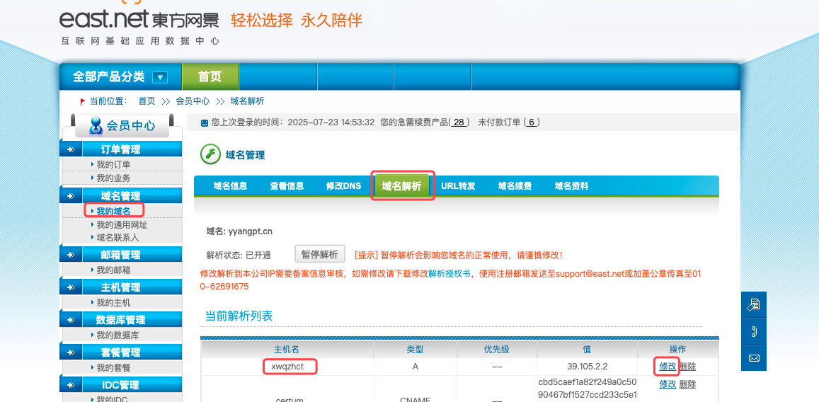

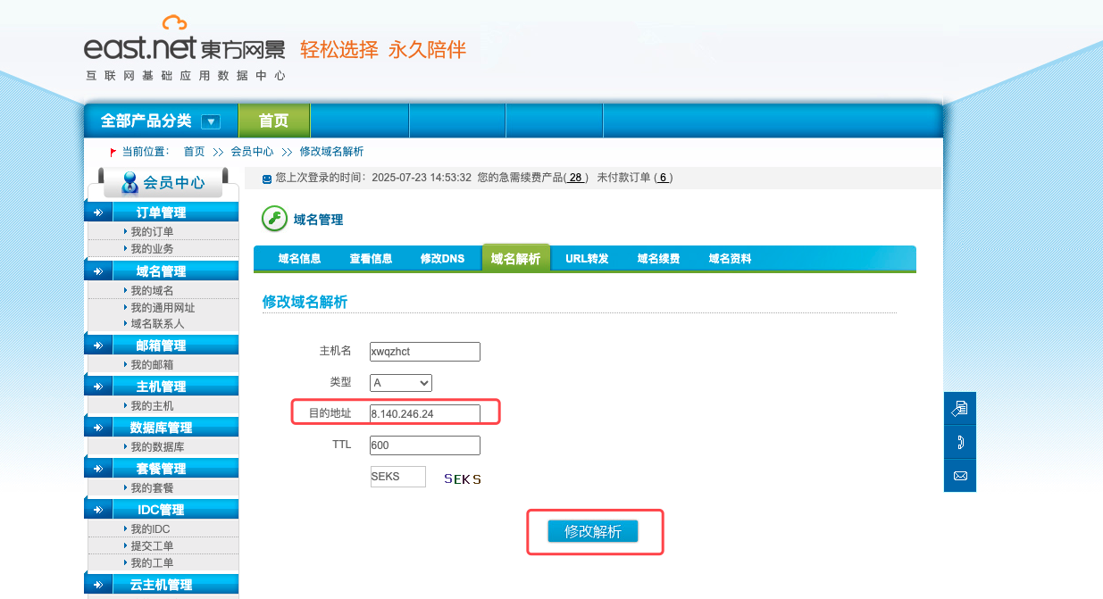


验证是否成功
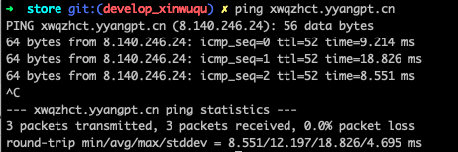
2.新建数据库zhct_sfd：copy产业园智慧餐厅zhct
1）zhct数据库同步数据结构到zhct_init
初始化数据
ydy_config
ydy_config_enum
ydy_menu
ydy_dish
ydy_dishes
ydy_dishes_tag
ydy_foods_composition
2）zhct_init 同步数据到 zhct_sfd
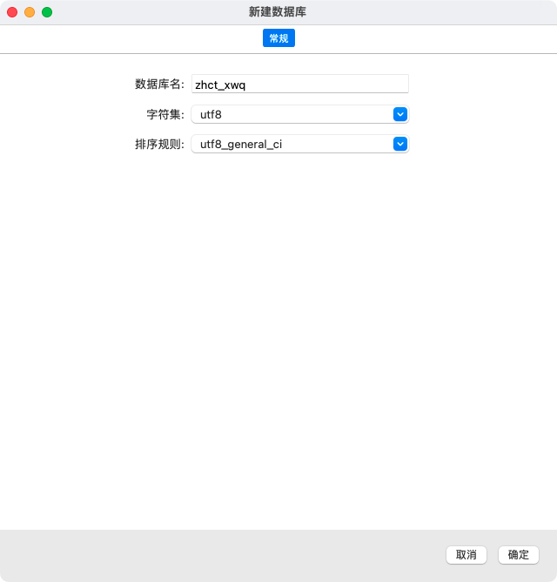

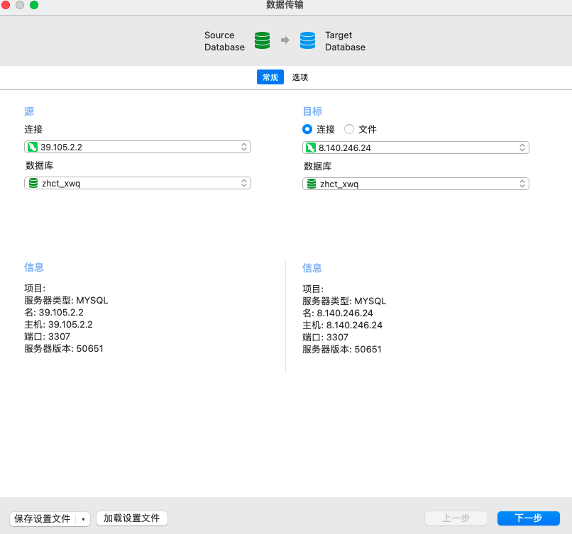
3.创建阿里云OSS图片存储目录
https://oss.console.aliyun.com/overview
在yyangpt创建zhct_sfd
oss-browser复制zhct_init 到 zhct_sfd
oss-browser本地工具速度更快
oss-browser位置： /Users/guodongwei/app/oss-browser-darwin-x64/oss-browser.app
配置数据库：oss-sql
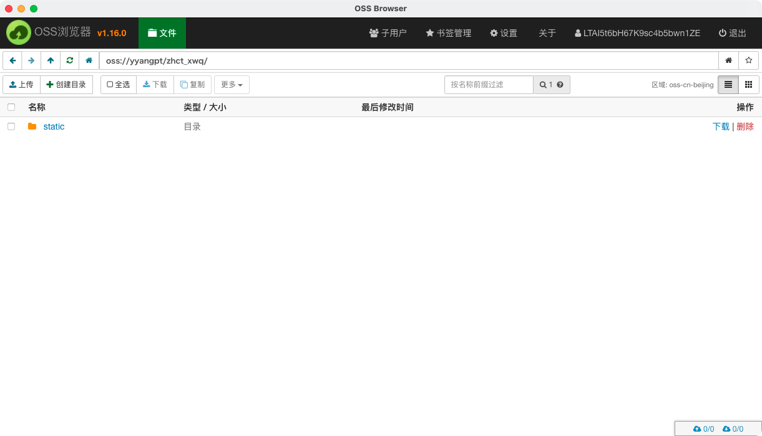
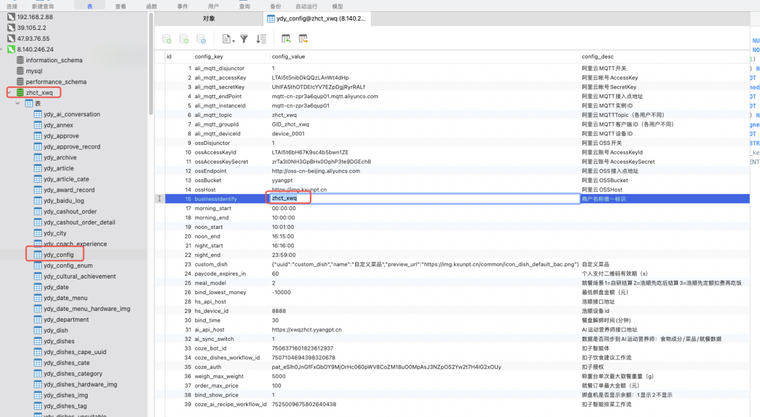
4.创建阿里云MQTT
https://mqtt.console.aliyun.com/region/cn-beijing/instance/mqtt-cn-kd54j95ip01/detail
topic：zhct_sfd
group：GID_zhct_sfd
配置数据库：mqtt-sql
配置用首通智城的配置
开启：ali_mqtt_shared_subscribe = 1

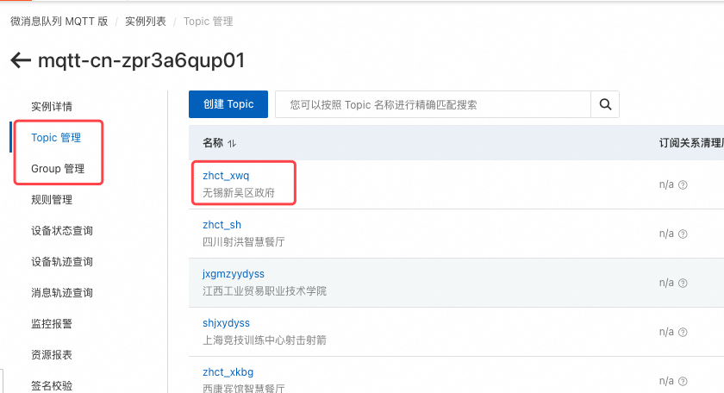
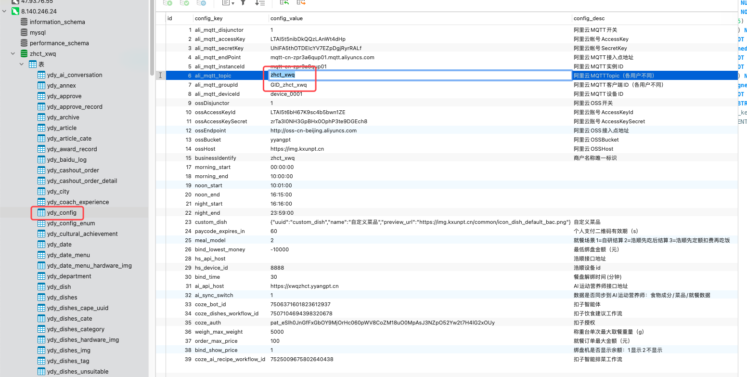
5.配置nginx
测试配置是否有语法错误:sudo nginx -t
重启nginx：nginx -s reload

vi /usr/local/nginx/conf/vhost/aizhctsfd.yyangpt.cn.conf
AI运动营养师服务器内部地址：
http://127.0.0.1:81
server
{
listen 81;
server_name 127.0.0.1;
index index.html index.php index.htm default.php default.htm default.html;
root /workspace/wwwroot/aizhct_sfd/project/public/;

location / {
if (!-e $request_filename) {
rewrite ^/(.*)$ /index.php/$1 last;
}
}

add_header X-Content-Type-Options: nosniff;
add_header X-XSS-Protection "1; mode=block";
add_header Content-Security-Policy "manifest-src 'self'";

include enable-php7.4.conf;

location ~ .*\.(gif|jpg|jpeg|png|bmp|swf)$
{
expires 30d;
}

location ~ .*\.(js|css)?$
{
expires 12h;
}

location ~ /.well-known {
allow all;
}

location ~ /\.
{
deny all;
}

access_log /workspace/wwwlogs/aizhctsfd.yyangpt.cn.log main;
error_log /workspace/wwwlogs/aizhctsfd.yyangpt.cn.error.log debug;

}

vi /usr/local/nginx/conf/vhost/zhctsfd.yyangpt.cn.conf
智慧餐厅内部地址：
http://127.0.0.1:80
http://172.16.25.80:81
server
{
listen 80;
server_name 172.16.25.80 127.0.0.1;
index index.html index.htm index.php default.html default.htm default.php;
root /workspace/wwwroot/zhct_sfd/project/public;

add_header X-Content-Type-Options: nosniff;
add_header X-XSS-Protection "1; mode=block";
add_header Content-Security-Policy "manifest-src 'self'";

location ^~ /aizhct/ {
rewrite ^/aizhct/(.*)$ /$1 break;
proxy_pass http://127.0.0.1:81;

proxy_set_header Host $host;
proxy_set_header X-Real-IP $remote_addr;
proxy_set_header X-Forwarded-For $proxy_add_x_forwarded_for;
proxy_set_header X-Forwarded-Proto $scheme;
}

include rewrite/thinkphp.conf;
include enable-php.conf;

location ~ .*\.(gif|jpg|jpeg|png|bmp|swf)$
{
expires 30d;
}

location ~ .*\.(js|css)?$
{
expires 12h;
}

location ~ /.well-known {
allow all;
}

location ~ /\.
{
deny all;
}

access_log /workspace/wwwlogs/zhctsfd.yyangpt.cn.log main;
error_log /workspace/wwwlogs/zhctsfd.yyangpt.cn.error.log debug;
}

6.创建项目目录
mkdir -p /workspace/wwwroot
cd /workspace/wwwroot
mkdir -p zhct_sfd/current
mkdir -p zhct_sfd/project
mkdir -p /workspace/wwwroot/log
cd /workspace/wwwroot/log
mkdir -p zhct_sfd/cron
chown www:www -R zhct_sfd/
7.项目代码配置
config.php
项目名称
商户标识：zhct_sfd
日志路径
百度人脸库用户组
版本号
domain
微信配置
redis
redisIP：172.16.25.80
8.项目数据库配置
database.php
数据库IP：172.16.25.81
9.配置部署流水线，部署代码
部署流水线
https://flow.aliyun.com/pipelines/4319898/current
构建物上传地址
oss://yyangpt/zhct_xwq/resource/
https://img.kxunpt.cn/zhct_xwq/resource/zhct_47.tgz
47是部署构建物序号
10.定时任务脚本配置
store/application/cron/shell/prod/cron.yml
1.订单结算
2.自动生成能量脚本
3.推荐能量脚本
4.mq人脸同步
5.自研设备心跳状态检测
6.称重台远程排菜消息
7.智能排菜

#四方达
#订单结算
* * * * * sh /workspace/wwwroot/zhct_sfd/project/application/cron/shell/prod/meal_order.sh zhct_sfd
#自动生成能量
* * * * * sh /workspace/wwwroot/zhct_sfd/project/application/cron/shell/prod/sys_power.sh zhct_sfd
0 4,10,16 * * * sh /workspace/wwwroot/zhct_sfd/project/application/cron/shell/prod/sync_staff.sh zhct_sfd
#mq人脸同步（MQTT开启时需要配置）
* * * * * sh /workspace/wwwroot/zhct_sfd/project/application/cron/shell/prod/mqrepeat.sh zhct_sfd
#自研设备心跳状态检测
* * * * * sh /workspace/wwwroot/zhct_sfd/project/application/cron/shell/prod/check_equipment_heart.sh zhct_sfd
#称重台远程排菜消息（MQTT开启时需要配置）
* * * * * sh /workspace/wwwroot/zhct_sfd/project/application/cron/shell/prod/mqrepeat.sh zhct_sfd 1

11.修改菜单
ydy_menu
- 数据同步AI运动营养师接口配置
http://127.0.0.1:81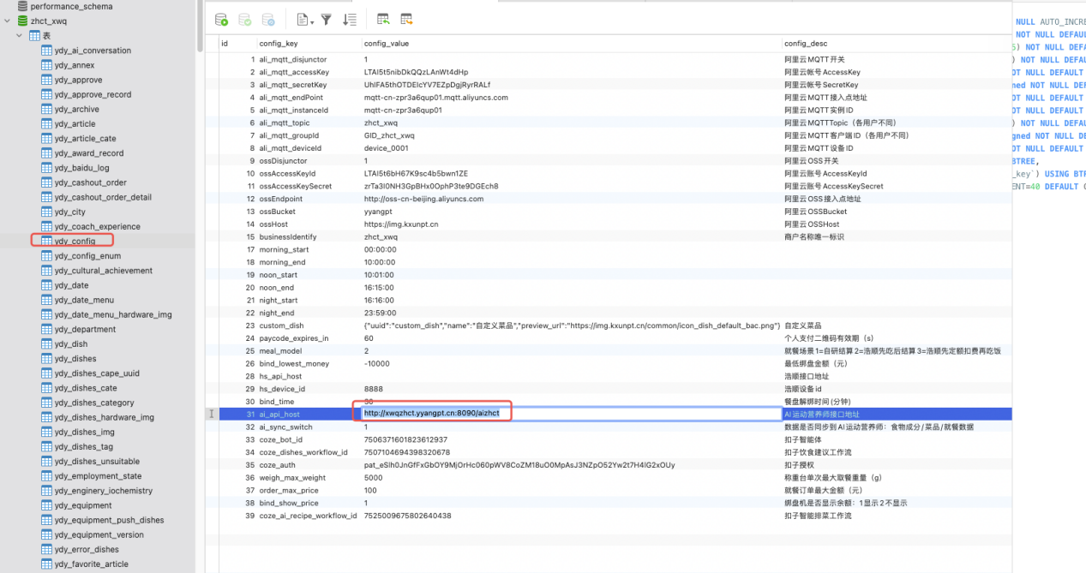
二、AI运动营养师：PC端+小程序端提供接口
小程序代码仓库：https://codeup.aliyun.com/60069db88deaa14d9e02b875/zhct/ai_app
代码分支：master
PC端前端代码仓库：https://codeup.aliyun.com/60069db88deaa14d9e02b875/zhct/ai_store
代码分支：master
部署流水线：https://flow.aliyun.com/pipelines/4013621/current
API代码仓库：https://codeup.aliyun.com/60069db88deaa14d9e02b875/zhct/ai_api
代码分支：master
部署流水线：https://flow.aliyun.com/pipelines/4014479/current
business:aizhct_sfd
1.新建域名
http://172.16.25.80/aizhct/
域名解析地址 http://127.0.0.1:81
2.新建数据库aizhct_sfd：copy产业园智慧餐厅aizhct

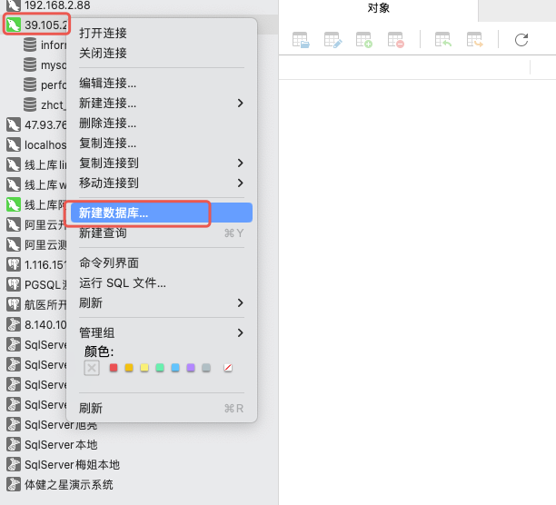
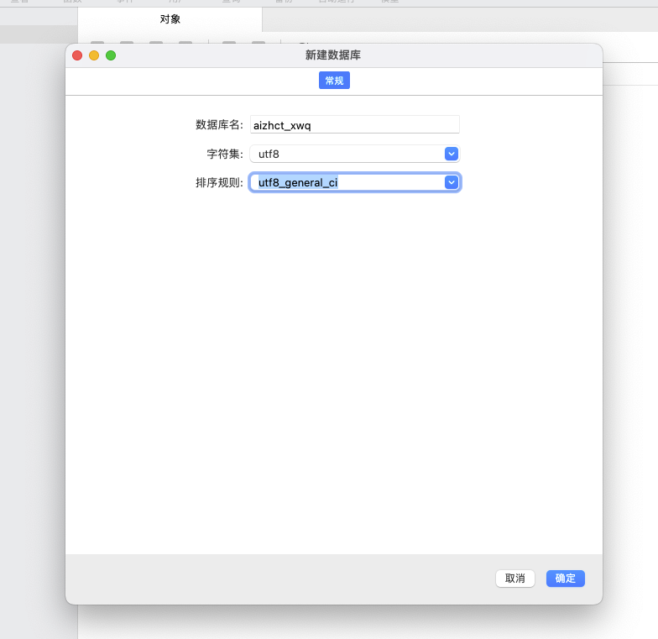
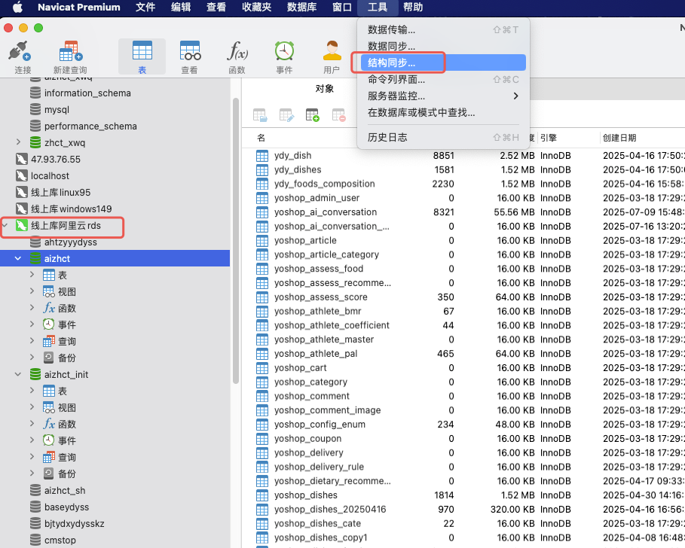

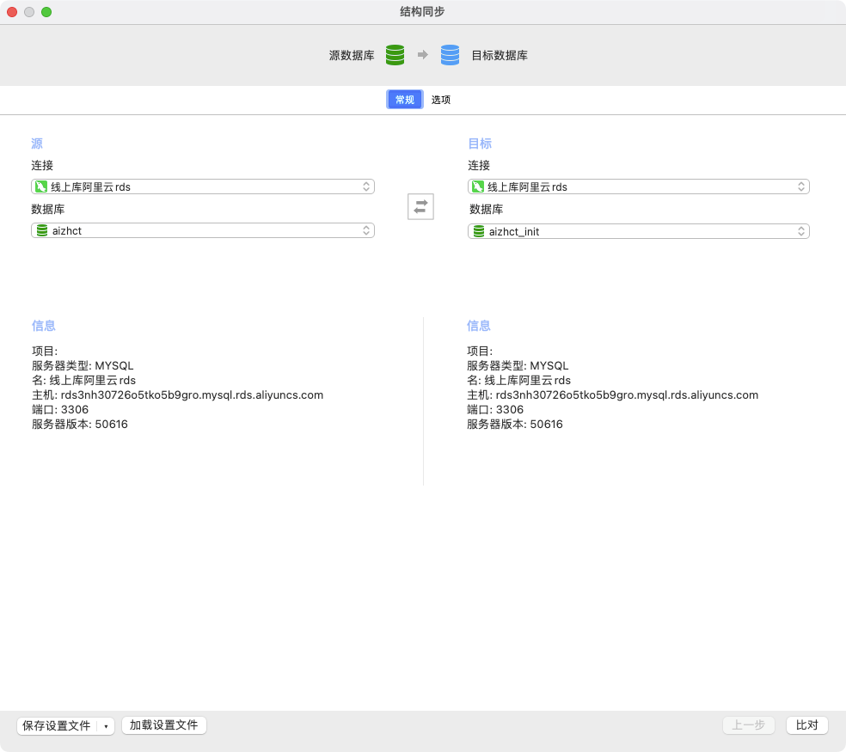
2）aizhct_init 同步数据到 aizhct_sfd
3)
yoshop_dishes.business=zhct_sfd 需要批量修改初始化数据
yoshop_dishes_relation.business=zhct_sfd 需要批量修改初始化数据
yoshop_foods.business=zhct_sfd 根据项目变更，需要批量修改初始化数据
yoshop_foods_relation.business=zhct_sfd 根据项目变更，需要批量修改初始化数据
update yoshop_dishes set `business`='zhct_sfd';
update yoshop_dishes_relation set `business`='zhct_sfd';
update yoshop_foods set `business`='zhct_sfd';
update yoshop_foods_relation set `business`='zhct_sfd';

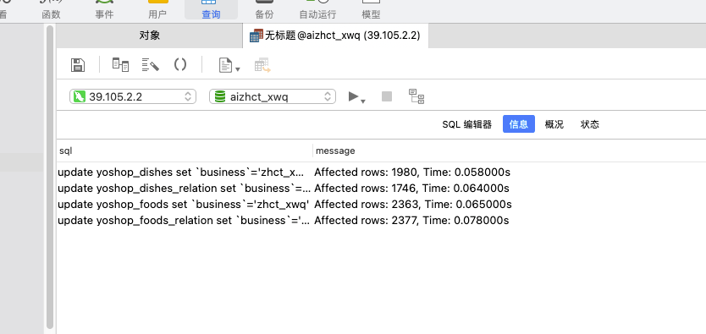
3.创建阿里云OSS图片存储目录
https://oss.console.aliyun.com/overview
在yyangpt创建aizhct_sfd
oss-browser复制aizhct_init 到 aizhct_sfd
oss-browser本地工具速度更快
oss-browser位置： /Users/guodongwei/app/oss-browser-darwin-x64/oss-browser.app
配置数据库：oss-sql
5.配置nginx 上面做过了
6.创建项目目录
cd /workspace/wwwroot
mkdir -p aizhct_sfd/current
mkdir -p aizhct_sfd/project
cd /workspace/wwwroot/log
mkdir -p aizhct_sfd/cron
chown www:www -R aizhct_sfd/
7.配置部署流水线
https://flow.aliyun.com/pipelines/4321922/current
新建流水线
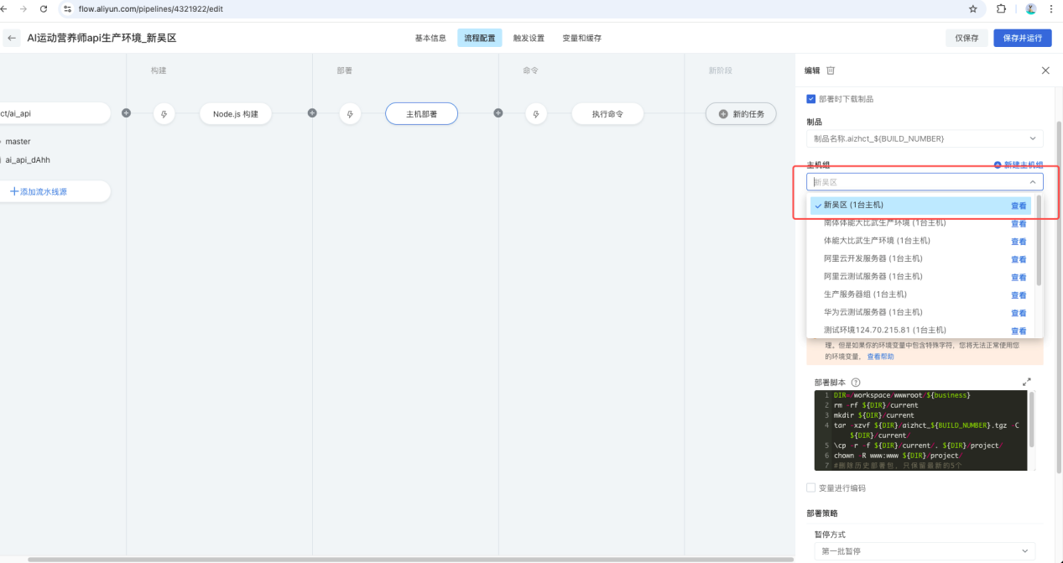
8.项目代码配置
.env.prodaizhct_sfd
config/business.php
9.项目数据库配置
小程序配置
人脸地址配置
redis配置

yoshop_h5_setting
yoshop_store
yoshop_store_setting
yoshop_wxapp_setting
10.定时任务脚本配置
#四方达
#AI运动营养师生成能量脚本
01 0 * * * /usr/local/php7.4/bin/php /workspace/wwwroot/aizhct_sfd/project/think staffPower
- 配置守护进程
10.守护进程配置
cp /workspace/wwwroot/zhct_sfd/project/application/cron/shell/prod/supervisor/sfd/* /etc/supervisor/conf.d/
# 重新加载配置文件 ：当您新增或修改 Supervisor 配置文件时，运行
sudo supervisorctl reload
sudo supervisorctl update
/usr/local/bin/supervisorctl update
12.uniapp项目多商户配置 企业编号
13.小程序授权配置
三、AI运动营养师PC端
https://flow.aliyun.com/pipelines/4323012/current

下载代码压缩包
智慧营养健康餐厅商户端生产环境_四方达
https://flow.aliyun.com/pipelines/4319898/current
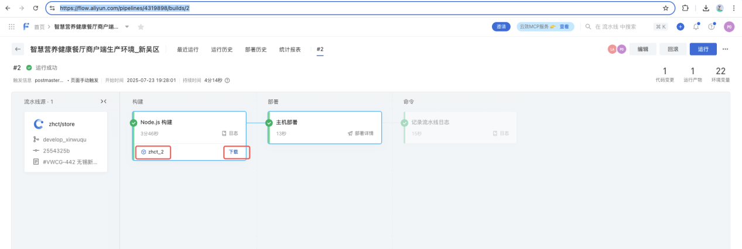
AI运动营养师商户端生产环境_四方达
https://flow.aliyun.com/pipelines/4323012/current
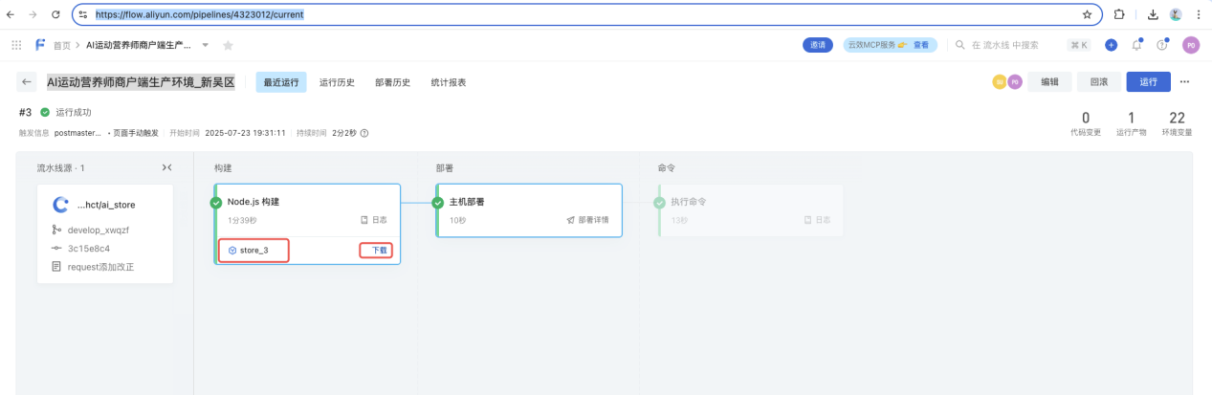
AI运动营养师api生产环境_四方达
https://flow.aliyun.com/pipelines/4323012/current
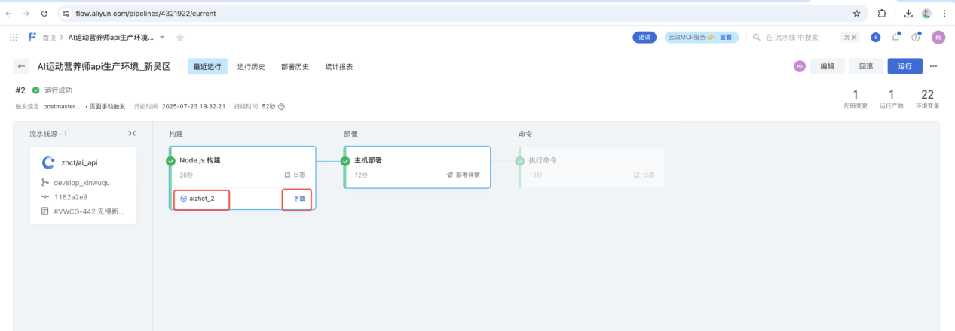

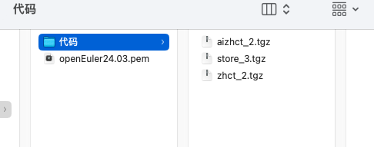

➜ 代码 pwd
cd /Users/guodongwei/Desktop/智慧餐厅/项目/四方达/服务器/代码
➜ 代码 ll
total 121264
-rw-r--r--@ 1 laiqingtao staff 8.8M 7 23 19:35 aizhct_2.tgz
-rw-r--r--@ 1 laiqingtao staff 5.6M 7 23 19:44 store_3.tgz
-rw-r--r--@ 1 laiqingtao staff 41M 7 23 19:34 zhct_2.tgz
代码上传到服务器
注意修改对应的序号
#智慧营养健康餐厅商户端生产环境_四方达
scp /Users/guodongwei/Desktop/智慧餐厅/项目/四方达/服务器/代码/zhct_7.tgz root@172.16.25.80:/workspace/wwwroot/zhct_sfd

#AI运动营养师商户端生产环境_四方达
scp /Users/guodongwei/Desktop/智慧餐厅/项目/四方达/服务器/代码/store_3.tgz root@172.16.25.80:/workspace/wwwroot/aizhct_sfd

#AI运动营养师api生产环境_四方达
scp /Users/guodongwei/Desktop/智慧餐厅/项目/四方达/服务器/代码/aizhct_2.tgz root@172.16.25.80:/workspace/wwwroot/aizhct_sfd

密码：
aliyun2025.
解压部署
注意修改对应的序号
登录服务器
ssh root@172.16.25.80
aliyun2025.
#智慧营养健康餐厅商户端生产环境_四方达
DIR=/workspace/wwwroot/zhct_sfd
rm -rf ${DIR}/current/*
#rm -rf ${DIR}/project/*
tar -xzvf ${DIR}/zhct_7.tgz -C ${DIR}/current/
#删除前端构建后代码
rm -rf ${DIR}/project/public/dist
rm -rf ${DIR}/project/public/phone
rm -rf ${DIR}/project/public/Console
\cp -r -f ${DIR}/current/* ${DIR}/project/
chmod -R 755 ${DIR}/project/
chown -R www:www ${DIR}/project/
#删除历史部署包，只保留最新的5个
ls -t ${DIR}/zhct_*.tgz | tail -n +6 | xargs -d '\n' rm -f
echo "部署完成"

#AI运动营养师商户端生产环境_四方达
#压缩包地址
DI=/workspace/wwwroot/aizhct_sfd
#项目地址
DIR=/workspace/wwwroot/zhct_sfd
rm -rf ${DIR}/project/public/store
mkdir ${DIR}/project/public/store
tar -xzvf ${DI}/store_3.tgz -C ${DIR}/project/public/store/
#删除历史部署包，只保留最新的5个
ls -t ${DIR}/store_*.tgz | tail -n +6 | xargs -d '\n' rm -f
echo "部署完成"

#AI运动营养师api生产环境_四方达
DIR=/workspace/wwwroot/aizhct_sfd
rm -rf ${DIR}/current
mkdir ${DIR}/current
tar -xzvf ${DIR}/aizhct_2.tgz -C ${DIR}/current/
\cp -r -f ${DIR}/current/. ${DIR}/project/
chown -R www:www ${DIR}/project/
#删除历史部署包，只保留最新的5个
ls -t ${DIR}/aizhct_*.tgz | tail -n +6 | xargs -d '\n' rm -f
echo "部署完成"
测试功能
智慧营养健康餐厅
http://sfdzhct.yyangpt.cn:8090
AI运动营养师
http://sfdzhct.yyangpt.cn:8090/aizhct/store

